

Social Studies GA Milestones Study Guide: 5th Grade

**People of the Civil War and their roles**

**Abraham Lincoln –** President during the Civil War; sign the Emancipation Proclamation which ended slavery

**Robert E. Lee –** Lead the *Confederate Army* (South)

**Ulysses S. Grant –** Lead the *Union Army* (North)

**Jefferson Davis –** Elected president of the Confederate States of America in 1861 and remained president throughout the Civil War.

**Thomas “Stonewall” Jackson –** Confederate General who was very brave and was nicknamed “Stonewall” because the Union soldiers had difficulty winning against him.

**Major Civil War Battles**

**Fort Sumter –** first battle of the Civil War

**Gettysburg –** battle that was the turning point for the North

**The Atlanta Campaign –** General Sherman (Union) marched south to GA to destroy the morale (how people feel) of the South

**Sherman’s March to the Sea –** After destroying Atlanta, General Sherman continued to the Atlantic Ocean with the hope that if he destroyed everything in his path, the South would give up

**Appomattox Court House –** Where Robert E. Lee (South) surrendered. END OF THE CIVIL WAR!

**Impact on the Civil War**

**Uncle Tom’s Cabin** – was one of the many reasons for the Civil War: It outraged people as they learned about the horrors of slavery through reading this book

**John Brown’s raid on Harper’s Ferry –** John Brown planned on raiding a military armory (place where the military kept guns and ammunition) and then give the weapons to slaves so they could fight for their freedom. Brown was caught and hung for treason. This incident got people talking negatively about slavery.

**How the issue of states’ rights and slavery increased tensions between the North and South –** the Southern states thought they had the right to own slaves; the Northern states did not. This created a major divide between the Northern and Southern states whereas brothers now fought brothers; cousins fought cousins (based on where you lived).

**Effects of war on the North and South –** Many Americans died but the conclusion of the war is that slavery was abolished (slavery ended).

**How life changed in America at the turn of the century**

**Black Cowboys of Texas** – some former slaves did not what to do with their lives after slavery was over; some became known as Black Cowboys and began proving themselves in the areas of horse riding, gun shooting, roping cows and bulls, and many other cowboy skills.

**Cattle Trails -**

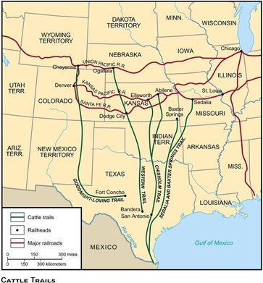

**Effects of Reconstruction on American life**

**13th Amendment –** made slavery illegal

**14th Amendment –** gives citizens equal rights

**15th Amendment –** gave all MEN the right to vote (former slaves)

**Freedmen’s Bureau –** government group to help with the transition from being a slave to being a citizen (the transition was only going to last one year) and help former slaves with finding family members, education, and gain land

**Sharecropping –** Now that black people were no longer slaves, what could they do??? Many began working for the same people who were their slave owners; but now as sharecroppers. They had to give up 50% of their profits to the owners of the land. Former slaves still had a *VERY difficult life.*

**How were African Americans prevented from exercising their newly won rights –** literacy tests were used to keep former slaves and poor white people from voting

**Jim Crow laws –** common phrase associated with Jim Crow laws is “separate but equal”; white citizens thought by giving black citizens the same rights but keeping African Americans away from white people was fair. This was quite the opposite.

**The Great Western Cattle Trail –** Originated by Captain John T. Lytle and several others taking 3,500 longhorn cattle from Texas to Nebraska.

**Chisholm Trail –** Trail from Texas to Kansas to send cows/meat to the east where cattle went as high as $50 a head compared to $3 in Texas!

**Wright brothers (flight) –** experimented with different types of airplanes; built the first known airplane

**George Washington Carver (science) –** former slave; known for “farmer science” and created over 105 food recipes and promoted about 100 products that can be made from peanuts.

**Alexander Graham Bell (communication) –** inventor who made the telephone

**Thomas Edison –** amazing inventor; invented things like bulb, phonograph, and the motion picture camera

**William McKinley –** President that started the Panama Canal but was assassinated.

**Theodore Roosevelt –** President who finished the Panama Canal.

**Spanish American War –** This was the first time the United States got involved in overseas issues. They came to the defense of Cuba who was rebelling against Spain. The United States was successful and claimed the Philippines, Guam and Puerto Rico as their own territories. Cuba gained its independence from Spain

**Panama Canal –** President McKinley worked on building a shortcut through Central American for transporting goods to the west coast.

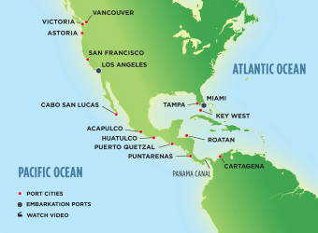

**Emigration to the United States –** America is also called the Melting Pot because it is a mixture of so many different races of people. Many people from different countries came to America for a better life (Italians, Russians, Germans, British, Canadians, Irish, Swedish)– Ellis Island was the most famous immigration site: located in New York

**United States – post WWI**

* Treaty of Versailles – document signed that ended the war: Germany did not want to sign this; many thought this was not the end of Germany fighting other countries
* No one really won the war – many people died in all the countries who were involved ☹
* WAR = BIG PROFITS!!!
* However, factories that were making tanks and planes now made cars and stoves
* Many women joined the war which led to the 19th Amendment: Women’s right to vote

**U.S. involvement in World War I**

* WWI began in 1914 when the Archduke Ferdinand of Austria Hungary was assassinated
* The United States DID NOT want to join the war in support of the Allies…at first
* In 1915 because the Germans sunk the Lusitania, a passenger ship, killing 128 American citizens…and still, the U.S. did not join the war (Germany ‘promised’ not to attack anymore U.S. ships)
* U.S. added A LOT of supplies and military soldiers
* However, in 1917, the Germans attacked more U.S. ships. The U.S. reluctantly joined the war

**Westward expansion impact on Native Americans –** the movement interrupted the Native American way of life and soon the settlers took over the entire area and moved the Native Americans off their land

**Battle of Little Bighorn –** This is also known as Custer’s Last Stand. General Custer disobeyed orders and took his army and attacked what he thought was a small Native American tribe. Little did he know there were three time this amount over a bluff. Quickly finding himself outnumbered, the Native Americans under the command of Sitting Bull wiped out Custer and his men.

**Relocation of Native Americans to reservations –** VERY controversial government policy that moved the Native Americans off their lands for western Americans settlers. The Native Americans were moved to lands not nearly as good as the lands they were living on.

**Great Depression –** 25% of Americans couldn’t find jobs

* Stock Market Crash of 1929 – businesses were making money so people started investing and borrowing $$$ from the banks; when the stock market leveled out/declined, people couldn’t pay the banks back – everything CRASHED!

**Herbert Hoover –** President during the Great Depression

**Dust Bowl –** farmers tilled up miles of land instead of a small area; when the drought hit, the tilled up land that the farmers couldn’t get to and turned to dust; when the wind hit, it created a “Dust Bowl”

**soup kitchens –** people out of work could come here for free food

**Franklin Roosevelt –** President elected after Hoover: he made The New Deal

**The New Deal –** created many jobs for people out of work and government assisted programs

**Civilian Conservation Corps –** hired men ages 18-26 to do mostly outdoor projects like planting trees and helping with national parks

**The Works Progress Administration –** provided millions of jobs (build roads, bridges, parks, and airports

**The Tennessee Valley Authority -** new jobs to build dams which provided hydroelectric power to TN, N.GA, N. AL, and the whole river valley

**The Roaring Twenties –** prosperous time for Americans in the 1920’s

**Jazz Age** (Louis Armstrong) – brought live music to life: people started paying for live events for the first time

**Baseball** (Babe Ruth) – made baseball famous with his homeruns

**The Harlem Renaissance** (Langston Hughes) – wanted to show people black people were good at art, music, and sports too

**The automobile** (Henry Ford) – made the Ford car; invented the ASSEMBLY LINE which enabled cars to be built quickly

**The airplane** (Charles Lindbergh) – first pilot to fly solo across the Atlantic Ocean

* Many countries were ‘broke’ and borrowed money from the U.S. which made them a more powerful country
* Businesses were doing well so more people began investing in stocks – this caused businesses to ‘boom’ even more – this began the Roaring Twenties – known for a period of prosperity

**WWII Continued…**

* President Truman dropped an atomic bomb on Hiroshima and Nagasaki to reduce the number the deaths of American soldiers; Japan surrendered after the second bomb in Nagasaki (over 200,00 Japanese died b/c of these bombs)
* Franklin D. Roosevelt – President during WWII
* Stalin - in charge of Soviet Union – fought with Germany in WWI; now with the Allies during WWII
* Churchill – Prime Minister of Great Britain during WWII
* Hirohito – Japanese Emperor during WWII
* Truman – gave the order to drop the atomic bombs
* Mussolini – Prime Minister of Italy
* Hitler – Main ‘bad-guy’ of WWII/Germany
* Rosie the Riveter – fictional women during WWII to get women involved in the war
* Tuskegee Airmen – first African American pilots

**World War II**

* War in Europe – WWII began with Hitler’s invasion of Poland in 1939
* United States once again remained neutral
* War in Asia – Japan brutalized Manchuria and China so the U.S. put an embargo (ban) on exports of oil and steel to Japan
* Pearl Harbor – Japan’s surprise attack on U.S. (Hawaii)…this made the U.S. enter WWII
* Iwo Jima – Japanese jungle that the U.S. struggled to take from Japan but played a crucial role in defeating the Japanese
* D-Day – U.S and Britain stormed the beaches of Normandy – many soldiers died
* VE and VJ Days – VE = Victory Europe and VJ = Victory Japan
* The Holocaust – Hitler was in charge of Nazi Germany and wanted eliminate people he thought did not belong in the world – the Nazis murdered over 11 million people; 6 million of the 11 were Jews

**1930’s Culture**

**Duke Ellington –** popular African American jazz musician

**Margaret Mitchell –** Wrote Gone With the Wind – a book about life in the South during the Civil War: won the Pulitzer Prize

**Jesse Owens –** African American who won 4 gold medals in 1936 in GERMANY – the main opposition to the Allies in WWI

**Important People & Events 1950-1975**

* Cuban Missile Crisis – President Kennedy imposed a blockade around Cuba; Cuba thought that meant U.S. wanted to go to war so the Soviet Union ‘gave’ Cuba some nuclear missiles; it was the closest the U.S. got to firing missiles during the Cold War.
* The Vietnam War – U.S. lost the Vietnam War – lasted 20 years; many Americans did not think the U.S. should be there fighting
* Civil Rights movement – fight for equality for ALL people
* Brown v. Board of Education (1954) – end segregation in schools
* The Montgomery Bus Boycott – African Americans boycotted (not use) the bus company after Rosa Parks was arrested for not giving up her seat on a bus to a white person
* The March on Washington – 250,000 people peacefully marched in Washington for equal rights
* Civil Rights Act– outlawed ANY form of discrimination
* Voting Rights – outlawed discriminatory voting practices that prohibited poor and illiterate people from voting

**Cold War –** war of ideas, words, and threats. The Soviet Union and United States developed atomic weapons and planted spies in each other’s country.

* Iron Curtain – After WWII, Soviet Union claimed control of Europe and guarded the borders so no one could leave to go to other countries
* Communism – government idea to share everything and give up control of your belongings when asked
* Berlin airlift – Great Britain and U.S. maintained control of West Berlin so Stalin could not gain ground
* The Korean War – After WWII Korea broke up into two Koreas (South Korea and North Korea) and have been fighting each other ever since
* The North Atlantic Treaty Organization (NATO) – treaty between U.S., Canada, and other European countries to help each other stay protected against the Soviet Union
* Joseph McCarthy – Term *McCarthyism* means a witch hunt; Republican who put a witch hunt out for any Communists in the U.S.
* Nikita Khrushchev – he led the Soviet Union during the Cold War

**United Nations**

* The U.N. began after World War II to help maintain peace and prevent further World Wars. President Woodrow Wilson had attempted to create a similar organization after World War I called the League of Nations.

**Locate the following on a map:**

* **Grand Canyon –** in Arizona

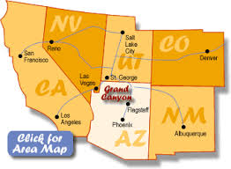

* **Salton Sea –** in California

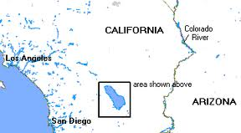

**Important People & Events 1950-1975 Continued**

* Thurgood Marshall – first black supreme-court justice judge
* Rosa Parks – fought for civil rights
* Martin Luther King, Jr. – civil rights activist through peaceful protesting
* JFK Assassination – well loved President; his assassination to this day is a mystery with Lee Harvey Oswald claiming he did not kill the President
* MLK Assassination – Martin Luther King was killed for what he believed in; equality for all
* Television – brought the world to the living room; news was able to spread in a faster/more visual way
* Space exploration – during the Cold War, the Soviet Union and U.S. were in a race to send the first person to the moon – this symbolized who the technology leader in the world was
* **Great Salt Lake –** Utah

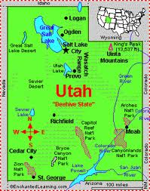

* **Mojave Desert –** Las Vegas

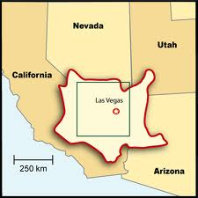

* **Chisholm Trail –** goes through Kansas, Oklahoma, and Texas

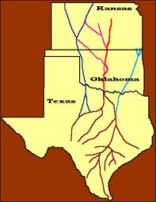

* **Pittsburgh, PA**

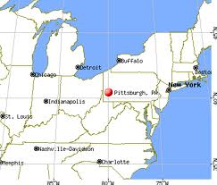

* **Gettysburg, PA**

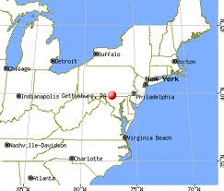

* **Kitty Hawk, NC**

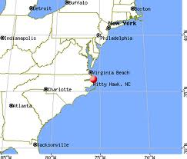

* **Pearl Harbor, HI**

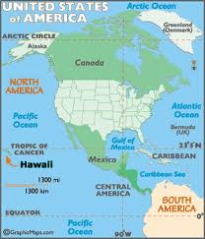

* **Montgomery, AL.**

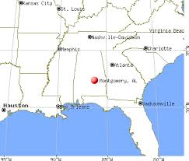

**How did factors such as population, transportation, and resources influence industrial location in the United States between the end of the Civil War and 1900?**

* Big business and inventors played a key role to prosperity
* Oil production was big – very important to live in an area where there was gold or oil
* many people immigrated to the U.S. – increased population means reduction in available jobs
* rapid transit like trains allowed people to work farther away from their homes
* skyscrapers (tall buildings) were built – Chicago
* steel cities – Pittsburg

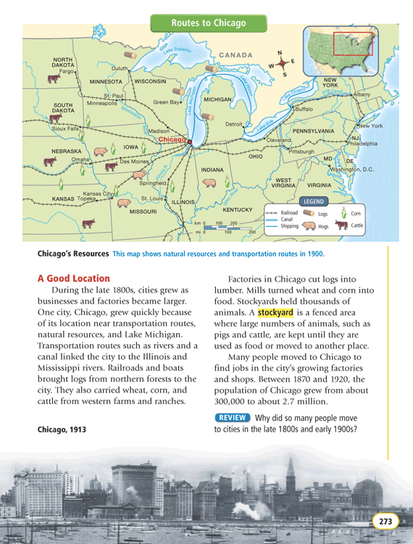

**Government/Civics**

* Citizen’s rights are protected by the *U.S. Constitution*
* Citizen’s have responsibilities – ‘rights’ are not free
* Bill of Rights
  + Amendment 1 – right for free speech
  + Amendment 2 – right to own guns
  + Amendment 3 – people cannot be forced to keep soldiers in their homes
  + Amendment 4 – cops need a warrant to search your property
  + Amendment 5 – you do not have to tell on yourself if you get in trouble
  + Amendment 6 – right to a jury
  + Amendment 7 – if sued, and amount is over $20.00, the case may be decided by a jury
  + Amendment 8 – right against cruel and unusual punishment
  + Amendment 9 – people have other rights than these listed
  + Amendment 10 – powers not given to the national government are given to the states
* Due process – states must respect all the legal rights owed to a person
* 12th Amendment – vote for a president every four years
* 17th Amendment – people living in their state votes for THEIR legislators (senators, etc)

**Four Major Sectors of the U.S. economy**

* household – said to be the most important of the four sectors – this is the production of goods for their own consumption (make clothes; garden)
* private business – small business owners stabilize the economy; keeps unemployment rates low; consumerism higher
* banks - banks lend people money for businesses, etc. They can also invest in other sectors which help the economy too
* government – help regulate business; keep people honest; people’s taxes help pay for industries that provide jobs

**Consumer and Business Interaction in the Economy**

* competition – keeps prices of products down
* monopoly – only one business sells something so the price is higher
* consumers – buy products
* businesses – sell products
* when products are discounted or on sale, people will buy more (Black Friday – day after Thanksgiving $59.1 BILLION in sales the weekend after Thanksgiving because of awesome deals)
* people ‘sell’ their labor (work) to businesses for money
* it takes a lot of money to make new products – people/companies take a risk to start a new business: “GOTTA SPEND $$$$ TO MAKE $$$”

**Economics**

Opportunity cost - what you have to give up to get something else (no snack for a week so you can buy a toy with your saved up $$$)

Scarcity - means there is not enough for everyone

Price incentives - when things are on sale…people shop!!! ☺

Specialization - each region can grow different things

* Georgia is known for cotton and peaches
* Florida is known for its ________________________________________???
* Voluntary exchange - trading
* Technological advancement
  + negative - cotton gin increased a need for more slaves
  + positive - computer increased the ability for a world community
* Having a personal budget will allow you to responsibly buy the things you want and need
* Example of personal budget
  + I was paid $500 this week
  + 10% goes to charity/tithing
  + 10% goes to me for WHATEVER I WANT
  + 10% goes to short term savings (buy a PS3/XBOX 360; emergencies)
  + 10% goes to long term savings (buy a car)
  + 60% goes to bills, food, gas, etc…
* Trade (barter) is the purist form of economics – people traded before money was printed; this helped people stay within their budget and not ‘overspend’ (credit cards)
* The computer and internet makes the economy go from local/national to global ---anyone can be a customer! ☺