Name __________________________________________________ Date _________________________________________
Tentative Test Date: _________________ | Georgia Performance Standards:  SS4H1 The student will describe how early Native American cultures developed in North America.  a. Locate where Native Americans settled with emphasis on the Arctic (Inuit), Northwest (Kwakiutl),  Plateau (Nez Perce), Southwest (Hopi), Plains (Pawnee), and Southeast (Seminole).  b. Describe how Native Americans used their environment to obtain food, clothing, and shelter.
Seminole | Pawnee | Hopi | Nez Perce | Kwakiutl | Inuit
Describe the houses the Seminole lived in. | Describe the houses the Pawnee lived in. | Describe the houses the Hopi lived in. | Describe the houses the Nez Perce lived in. | Describe the houses the Kwakiutl lived in. | Describe the houses the Inuit lived in.
Draw a picture of a Seminole house. | Draw a picture of a Pawnee house. | Draw a picture of a Hopi house. | Draw a picture of a Nez Perce house. | Draw a picture of a Kwakiutl house. | Draw a picture of a Inuit house.

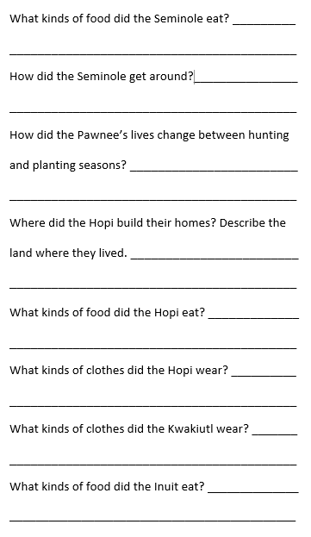
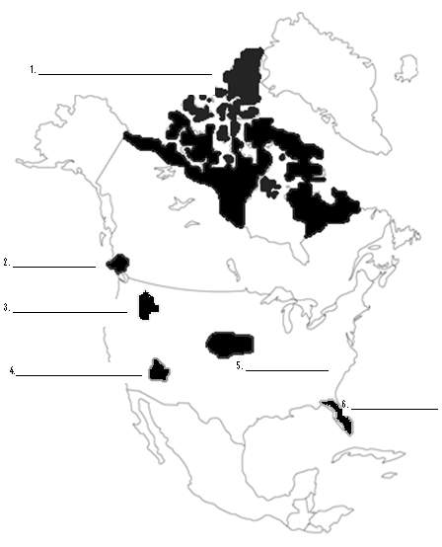
Label the tribes that lived in each of these areas. Know the tribes

