Answer the questions. You can use your Science journal or textbook to help.
axis | An imaginary straight line that runs through the center of the Earth at its poles.
rotate | To spin around on an axis.
revolve | To travel in a closed path.
orbit | The closed path that an object travels around another object.
waxing moon | The moon appears to grow because we can see more of its lighted surface. (think wax ON)
waning moon | The moon appears to get smaller because less of the lit surface can be seen. (think whine when things go away)
new moon | Shows none of the moon’s lighted side.
full moon | Shows all of the moon’s lighted side.
crescent moon | Only a sliver of the moon’s lighted side is shown.
gibbous moon | Only a sliver of the moon’s lighted side is NOT shown.
quarter moon | Half of the moon’s lighted side is shown.
solar system | A group of objects in space that orbit around a central star.
planet | A large object that orbits the sun in a consistent path.
constellation | A group of stars that form a “picture”.
telescope | A tool used to observe objects in space.

- What two ways does the Earth move?

- How do we get our day and night?

- Why do we have seasons?

- What are the phases of the moon? Label them. (full, new, crescent, gibbous, waxing, waning)
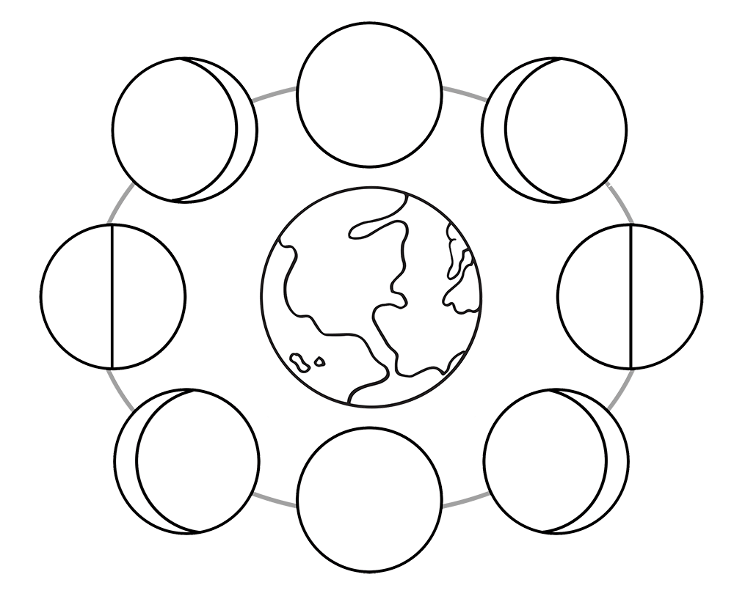

sun

- What does the color of a star tell us?
Blue- White- Yellow- Orange- Red-

- Planets in order according to the distance from the sun:
1- _______________________________ 2- _______________________________
3- _______________________________ 4- _______________________________
5- _______________________________ 6- _______________________________
7- _______________________________ 8- _______________________________

- Planets in order according to size (smallest to largest):

1- _______________________________ 2- _______________________________
3- _______________________________ 4- _______________________________
5- _______________________________ 6- _______________________________
7- _______________________________ 8- _______________________________
- What separates the inner planets and outer planets?

- What are the differences between inner planets and outer planets?

- Choose one planet that is your favorite. Be able to explain WHY with at least 3 details.
My favorite planet is __________________________________. It is an inner/outer planet. It is my favorite planet because
fact #1-
fact #2-
fact #3-
For all these reasons, __________________________________ is my favorite planet.

Earth rotates on its axis (day & night) | 24 hours
Moon orbits Earth (moon phases) | 29 ½ days
Earth orbits Sun (seasons) | 365 ¼ days
Leap Year | every 4 years because 4/4 = 1 more day

