Informative PowerPoint Book Report
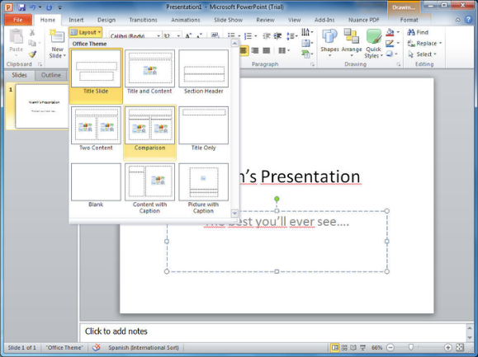
You will be creating PowerPoint presentation to represent the most important facts from your book.
Since the nonfiction genre is quite large, specific guidelines are tricky as to what exactly needs to be included. You have had experience with reading nonfiction text and conducting research. You will need to decide the most important information to include to show off that you truly understand your book.
- Read the nonfiction book once for gaining understanding.
- Read the nonfiction book a second time to gather notes. Set up your notes with subtopics, “buckets”, to gather facts that are alike.
- Decide on headings for your subtopics.
- You will be creating a slide to represent each of your subtopics.
- You must have a title slide that includes the title and author of your book.
- Your slideshow must include pictures that represent your facts.
- Your slideshow must have 6 slides minimum.
- Your presentation must not be READ but rather presented to the class.
TIPS:
*Please keep transitions to a minimum
*Choose one or two fonts to use throughout and a size that the audience can read
*Check spelling and grammar
*Try using phrases rather than complete sentences
*Try to keep it to 6 lines or less per slide
* When presenting a Power Point, do NOT read everything on the screen. Instead, choose the important things to TALK about. Make sure you make eye contact and speak clearly.

