

Math GA Milestones Study Guide: 5th Grade

**Pictographs –** (use when adding pictures to show data)

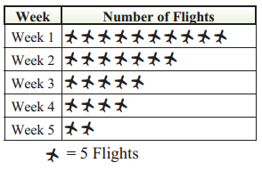

**Line Graph –** (use to compare something over a period of time)

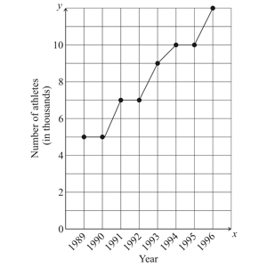

**Bar Graph** (use to compare things against other things)



**Using symbols for unknown numbers**

*  x 8 = ?
*  = 7
* 7 x 8 = 56

**Classify Triangles by their SIDES**

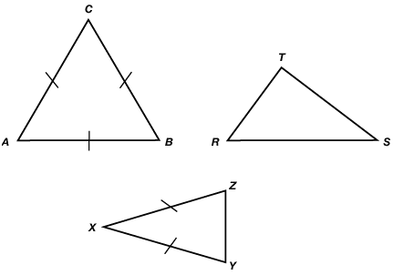

Triangle ABC - equilateral - all sides are equal

Triangle RST - scalene - no sides are equal

Triangle XYZ - isosceles - two sides are equal

**Classifying Triangles by their ANGLES**

acute triangle - less than 90’

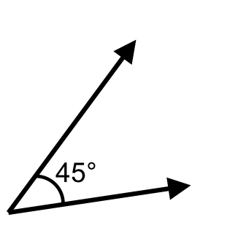

right triangle - 90’ (usually has a square in it)

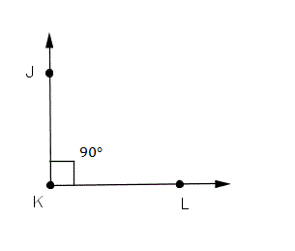

obtuse triangle - over 90’

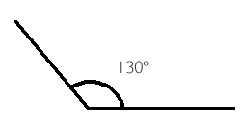

* **parallel lines -** two lines that run side by side ==========
* **perpendicular lines -** two lines that intersect making a cross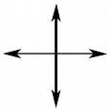
* **intersecting lines -** two lines that intersect making an X 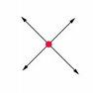

**Quadrilaterals**

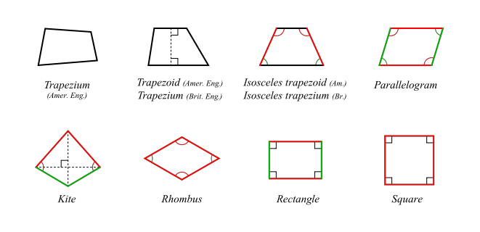

Faces - flat pieces

Edges - lines;

Vertices – corners

***LABEL THE CUBE BELOW***

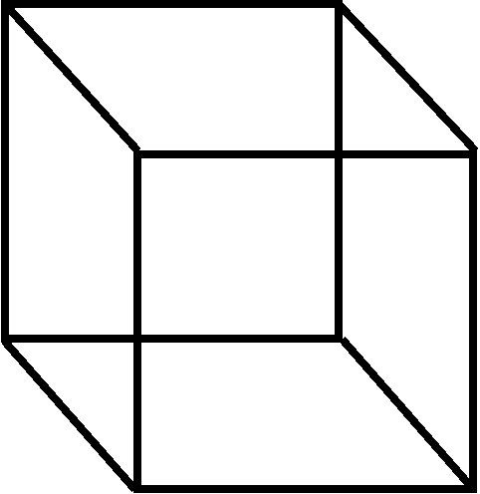 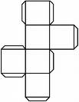 -unfolded cube

**Using a protractor -** if the angle is bigger than 90’, use the bigger numbers to tell the measurement of the angle.

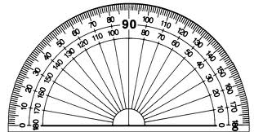

* Half of a rotation is 180’ (1/2 a circle)
* A full rotation is 360’ (a full circle)
* a 90’ rotation is ¼ - it takes 4(90’) to make one circle

**Coordinate System -** a basketball player DRIBBLES (left to right) first and then (up and down) SHOOTS

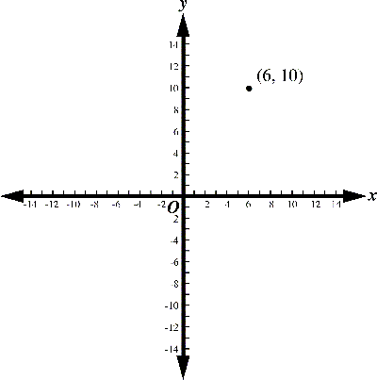

**Weight -** how heavy something is

* 16 ounces (oz) = 1 pound (lb)
  + 3lbs = 48 oz
  + 33 oz = 2 lbs 1 oz
* 2,000 lbs = 1 ton (T)
  + 7,000lbs = 3 ½ T
  + 8 T = 16,000 lbs
* 1,000 grams (g) = 1 kilogram (kg)
  + 5,500 g = 5 ½ kg
  + 6 kg = 6,000 g

**Place Value**

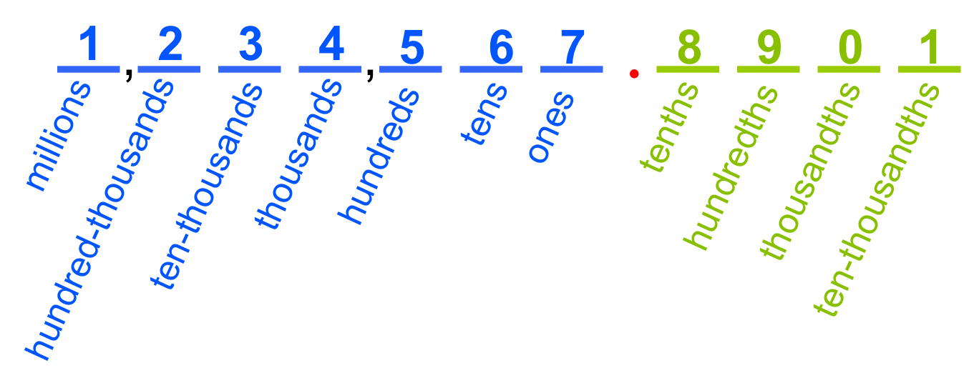

**Three ways to describe a number**

standard form: 7, 526

word form: seven thousand, five-hundred, twenty-six

expanded form: 7000 + 500 + 20 + 6

**Rounding/estimating numbers**

* If the digit after the one being rounded is less than 5 (0, 1, 2, 3 or 4), we round down.
* If the digit after the one being rounded is 5 or more (5, 6, 7, 8, or 9), we round up.
  + round to the nearest thousand: 5,633 = 6,000
  + round to the nearest hundred: 4,311 = 4,300
  + round to the nearest ten: 7,344 = 7,340

**Multiplication steps for:** 628 x 7

"7 times 8 is 56." Write 6, carry 5.

"7 times 2 is 14, plus 5 is 19." Write 9, carry 1.

"7 times 6 is 42, plus 1 is 43." Write 43

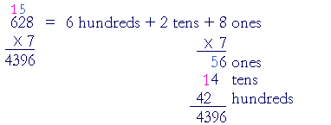

**Fractions**

* equivalent fractions: they equal the same
  + 1/2 (multiply the top AND bottom by any number - I chose 3)= 3/6
  + 2/3 (multiply the top AND bottom by any number - I chose 4)= 8/12

**Move the decimal over in the final answer when multiplying/dividing**



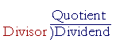

***KNOW THESE

**Decimals**

* line up your decimals when adding/subtraction



**Improper Fractions**

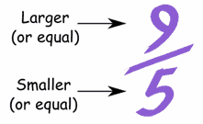 = 1 4/5

**Mixed Numbers**

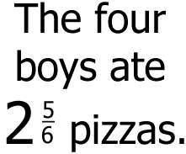 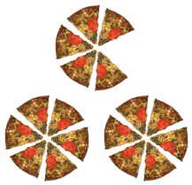

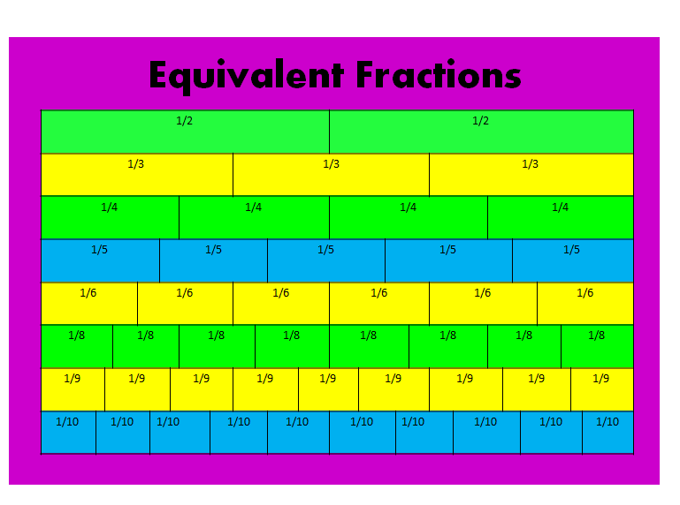

**Properties of Math**

Commutative Property

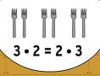

Associative Property

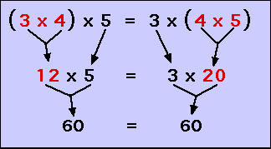

Distributive Property

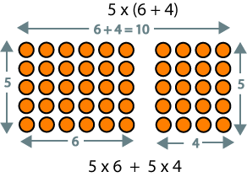

**Adding and subtracting fractions**

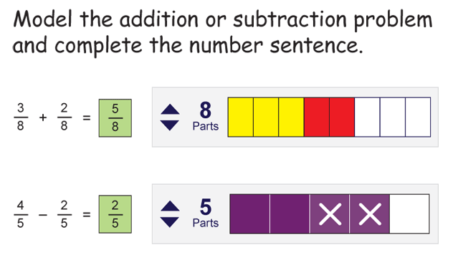

**Multiplying Mixed Numbers**

1) Convert each mixed number to an improper fraction.

2) Multiply the two numerators together.

3) Multiply the two denominators together.

4) Convert the result back to a mixed number if it is an improper fraction.

5) Simplify the mixed number.

Example: 5 2/3 * 4 3/5 =

1) Convert each mixed number to an improper fraction. 17/3 * 23/5

2) Multiply the two numerators together. 17 * 23 = 391

3) Multiply the two denominators together. 3 * 5 = 15

4) Convert the result to a mixed number. 391/15 = 26 1/15

5) Simplify the mixed number if necessary (not necessary for this problem)

**Multiplying Fractions**

Example: Multiply 3/9 and 4/12

1) Multiply the numerators (3*4=12)

2) Multiply the denominators (9*12=108)

3) Place the product of the numerators over the product of the denominators (12/108)

4) Simplify the Fraction (6/108 = 1/9)

**Comparing numbers and decimals: <, >, =**

* When decimals are compared start with tenths place and move to the hundredths place. If one decimal has a higher number in the tenths place then it is larger than a decimal with a lower number in the tenths column. If each decimal place value is the same then the decimals are equal.
  + .7 = 7/10 = 70 cents
  + .07 = 7/100 = 7 dollars
  + .6 > .4
    - SAME AS 6 > 4!
  + .23 < .59
    - SAME AS 23 > 59

**Volume of a Cube**

To find the volume of a cube, or a rectangular shaped solid, multiply together the lengths of each dimension.

Volume = length * width * height

By definition a cube has all three equal. So, for example, if a cube is 4 cm x 4 cm x 4 cm, then its volume is:

4 * 4 * 4 = 64 cm3

**Metric Volume**

1) A liter is the basic unit of volume

2) A deciliter is 1/10 liter

3) A centiliter is 1/100 liter

4) A milliliter is 1/1000 liter

**Measurement**

Multiplying feet to inches

1) Convert feet and inches to inches by multiplying the feet by 12 and adding the number of inches

2) Perform the required multiplication to determine the number of inches.

Convert the inches to feet and inches by dividing by 12.

3) The quotient is the number of feet and the remainder is the number of inches.

Example: Multiply 4 feet 8 inches times 4

Convert 5 feet to inches by multiplying 12 by 4:

12 * 4 = 48 inches

Add the number of extra inches:

48 + 8 = 56 inches

Perform the required multiplication:

56 * 4 = 224 inches

Convert to feet and inches by dividing by 12:

224 ÷ 12 = 18 R 8

The quotient (18) is the number of feet and the remainder (8) is the number of inches.

Answer: 18 feet 8 inches

**Multiplying gallons, pints, and quarts**

1) Convert gallons to pints by multiplying the number of gallons by 8.

2) Convert quarts to pints by multiplying the number of quarts by 2.

3) Add the above quantities and the number of original pints together.

4) Perform the required multiplication to determine the number of pints.

5) Convert the pints to gallons by dividing by 8.

6) The quotient is the number of gallons and the remainder is the number of extra pints.

7) Convert the extra pints to quarts by dividing the extra pints by 2.

8) The quotient is the number of quarts and the remainder is the number of pints.

Example: Multiply 4 gallons 3 quarts and 1 pint times 5

1) Convert 4 gallons to pints by multiplying 8 by 4:

*8 * 4 = 32 pints*

2) Convert 3 quarts to pints by multiplying 3 by 2:

*3 * 2 = 6 pints*

3) Add the pints from above and the number of original pints:

*32 + 6 + 1 = 39 pints*

4) Perform the required multiplication:

*39 * 5 = 195 pints*

5) Find the number of whole gallons by dividing by 8:

*195 ÷ 8 = 24 R 3*

6) Find the number of whole quarts by dividing the remainder by 2:

*3 ÷ 2 = 1 R 1*

7) The remainder of 1 is the number of pints.

8) Answer: 24 gallons 1 quart and 1 pint

**Determine and justify the fair share, range, mode, and median of a set of data**

**Find the mean, median, mode, and range for the following list of values:**

13, 18, 13, 14, 13, 16, 14, 21, 13

1) The fair share is the average:

(13 + 18 + 13 + 14 + 13 + 16 + 14 + 21 + 13) ÷ 9 = 15

2) The median is the middle value – REWRITE THE NUMBERS IN ORDER FROM LEAST TO GREATEST:

13, 13, 13, 13, 14, 14, 16, 18, 21

3) There are nine numbers in the list, so the middle one will be the (9 + 1) ÷ 2 = 10 ÷ 2 = 5th number:

13, 13, 13, 13, 14, 14, 16, 18, 21

The mode is the number that is repeated more often than any other: 13 is the mode.

The largest value in the list is 21, and the smallest is 13, so the range is 21 – 13 = 8.

Fair share: 15

median: 14

mode: 13

range: 8

Convert

8 tons = ___________lbs 15,000lbs = _________T 36 in = _________ ft

6ft = ________in 48hrs = _______ dys 120 min = ________hrs

Identify the # of: faces_________; edges ____________; vertices ____________

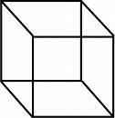

Greater than (>), less than (<), or equal (=)

4/8 ______ 3/6 54.45 ________ 45.54 788.55 ________ 99.999

2/3 ______ 7/8 centimeter ____inches feet ______yards

Round to the nearest thousand

3,554_________________6,999 ______________ 3,422 ________________

Round to the nearest hundred

8,234 _________________5,606 ________________9,999 _______________

Round to the nearest hundredths

45.89 _______________ 377.987______________ 340.32_________________