Lapbook/Brochure

You will be creating an all about foldable to represent the most important facts from your book.
Since the nonfiction genre is quite large, specific guidelines are tricky as to what exactly needs to be included. You have had experience with reading nonfiction text and conducting research. You will need to decide the most important information to include to show off that you truly understand your book.
- Read the nonfiction book once for gaining understanding.
- Read the nonfiction book a second time to gather notes. Set up your notes with subtopics, “buckets”, to gather facts that are alike.
- Decide on headings for your subtopics.
- Choose if you would like to create a lapbook (made from a file folder) or a tri-fold brochure (made from card stock). *A lapbook has more room for more subtopics or visuals.
- Please make sure to use your very best handwriting or typed text. Your artifact needs to include either drawings or pictures.
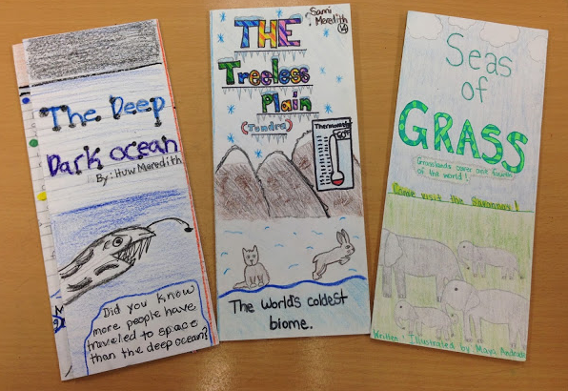
- Must include headings and facts. The lapbook/brochure should cover your topic thoroughly.

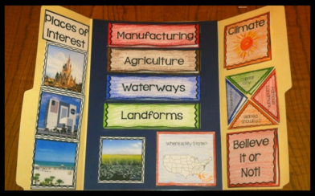

http://appletasticlearning.com/2015/03/17/how-to-make-lap-book/

