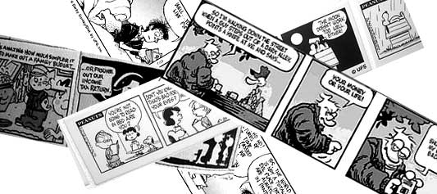
Comic Strip
Book Report
Choose a Historical Fiction book in your reading level.
Materials:
-large white construction paper -pencil
-think markers, colored pencils, or crayons -ruler
Planning:
Analyze the funny pages in the newspaper. Notice how comic strips can be varying lengths and designs. Note that not all comic strips are humorous.
Choose an important or exciting event from your historical fiction novel that you would like to retell in your comic strip. Find a part that will show action AND dialogue. Make sure you choose an event that CAN be told with a comic strip (discuss it with your parents or see me).
Drafting:
Start by creating a one-paragraph summary of the event you have chosen.
Create a blank comic strip with about 8 boxes using your large construction paper and ruler.
Decide upon dialogue in either speech bubbles or written as sentences to describe the scene. Create your illustrations to go with it. Make sure that your characters are identifiable in each scene so there is no confusion among who’s who.
Final Copy:
Make sure to use PENCIL first! Then, go over with marker or colored pencil. Your comic strip MUST be in color.
Give your comic a title. Include your name, the book title, and author’s name on your project.

