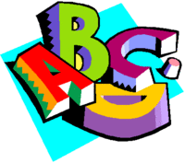
Alphabet Book of Facts
You will be creating an Alphabet Book to represent the most important facts from your book.
Since the nonfiction genre is quite large, specific guidelines are tricky as to what exactly needs to be included. You have had experience with reading nonfiction text and conducting research. You will need to decide the most important information to include to show off that you truly understand your book.
- Read the nonfiction book once for understanding.
- Read the nonfiction book a second time to gather notes. Set up your notes with subtopics, “buckets”, to gather facts that are alike.
- You will need at least 13 pages, a front, and back cover.
- Start by drafting ideas of facts that could represent each 26 letters of the alphabet. Some letters will be more difficult than others. You will need to be creative and think outside of the box.
- Write the capital and lowercase letter in the top outside corner of the pages. List the fact about your topic on the page in a complete sentence. Underline the featured word. Illustrate or include a picture to represent your fact.
Ee
Koala bears eat eucalyptus leaves. They do not drink water because they get all they need from the leaves.
